**Experiment No. 2**

**Title:**

Create a scenario in WordPress for Social Marketing, Search engine and Sharing Tools.

**Objective:**

To learn Software as service (SaaS) using Free trial of WordPress

**Tools used:**

Internet , WordPress

**Prerequisite:**

Understanding of Software as service in Service model of cloud computing

**Theory:**

WordPress started in 2003 when Mike Little and Matt Mullenweg created a fork of b2/cafelog. The need for an elegant, well-architected personal publishing system was clear even then. Today, WordPress is built on PHP and MySQL, and licensed under the GPLv2. It is also the platform of choice for over 43% of all sites across the web.

The WordPress open source project has evolved in progressive ways over time—supported by skilled, enthusiastic developers, designers, scientists, bloggers, and more. WordPress provides the opportunity for anyone to create and share, from handcrafted personal anecdotes to world-changing movements.

People with a limited tech experience can use it “out of the box”, and more tech-savvy folks can customize it in remarkable ways.

WordPress is a popular and widely used content management system (CMS) that allows users to create, manage, and publish content on the internet. It's an open-source platform, originally designed for blogging, but it has evolved into a versatile tool used for creating various types of websites, from simple blogs to complex e-commerce sites, portfolios, business websites, and more. It offers a user-friendly interface, a wide range of themes and plugins for customization, and doesn't require advanced technical knowledge to get started. Users can create and manage content, such as text, images, videos, and more, making it a flexible and accessible tool for building websites.

**Steps to create the account and Working**

**Step 1. - Creating Account For WordPress <https://wordpress.com/>** 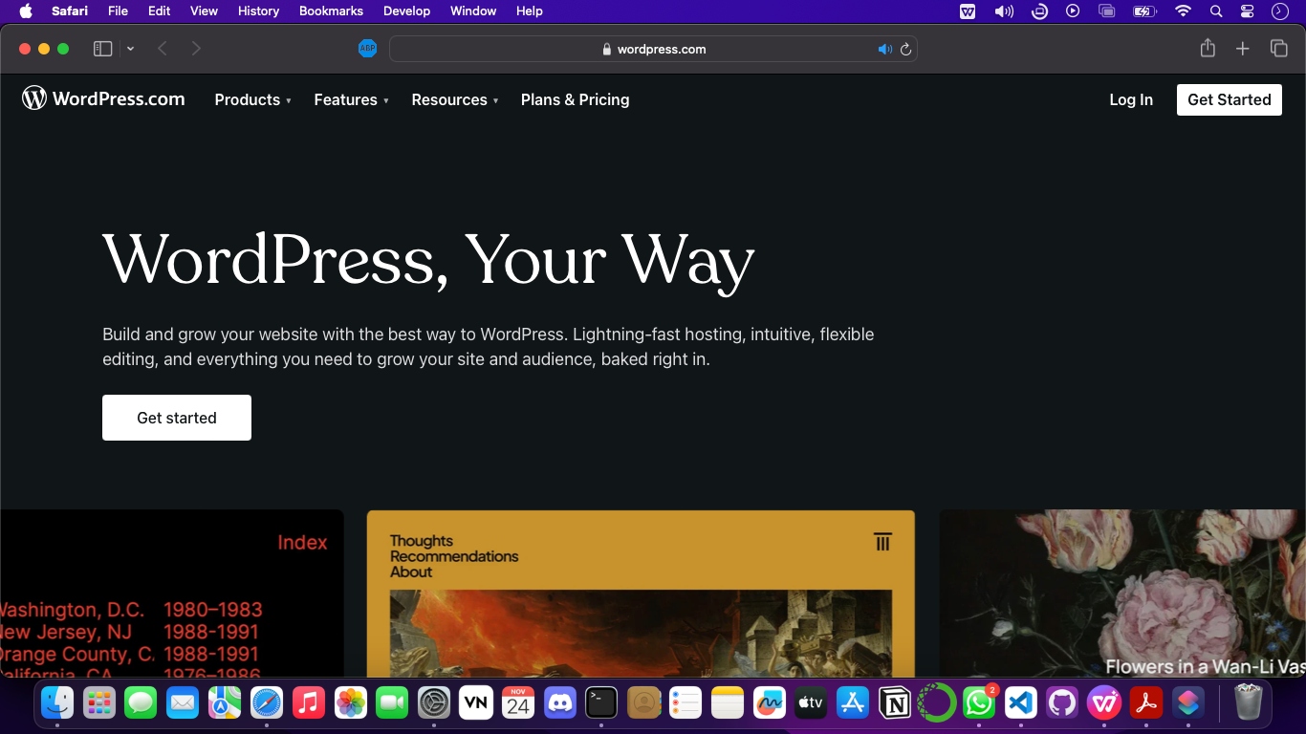

**Step 2. – Create your Account** 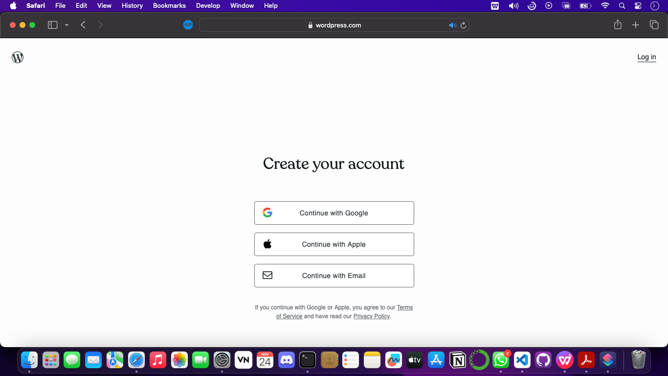

**Step 3 – Choose Domain or you can choose later**

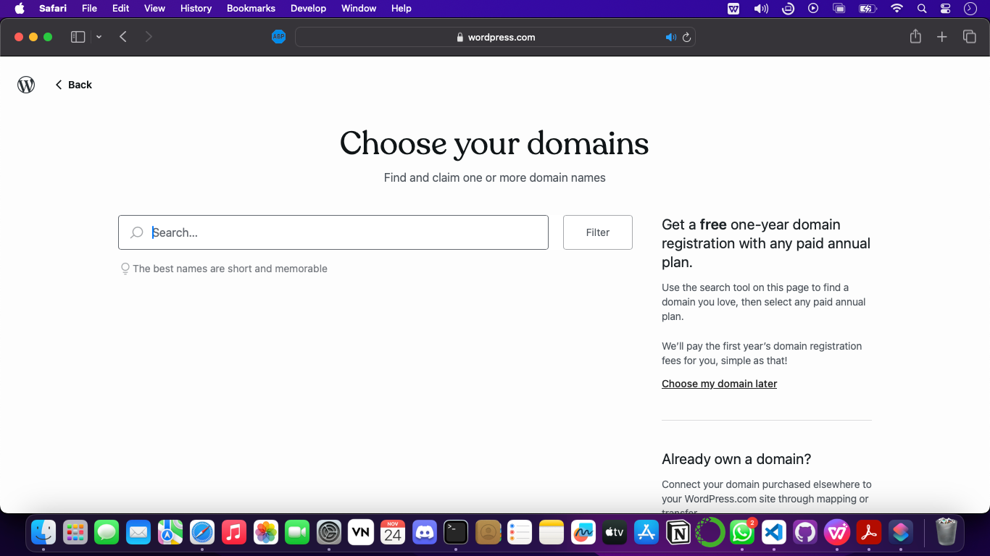

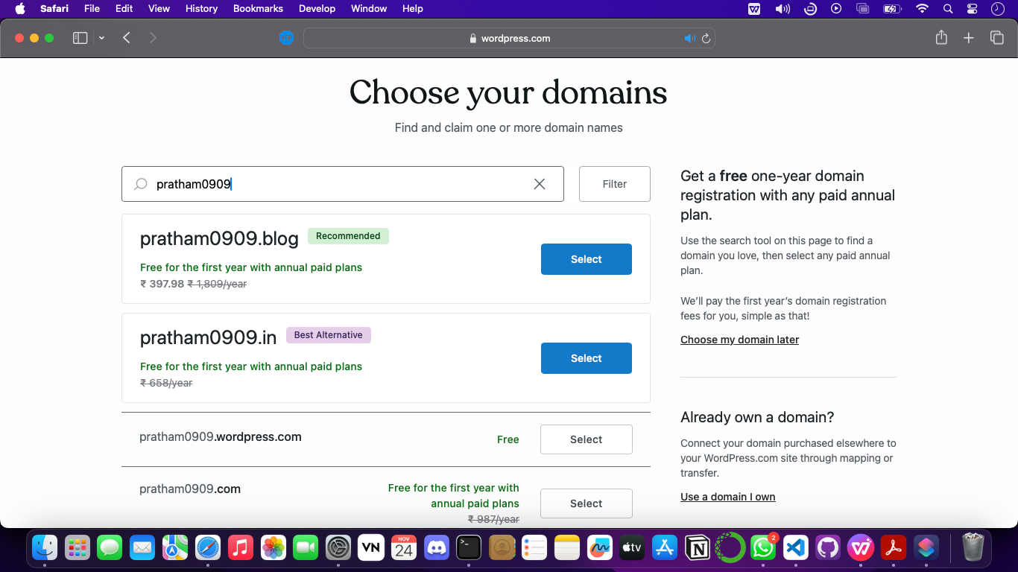

**Step 4 – Choose the plan for using the WordPress**

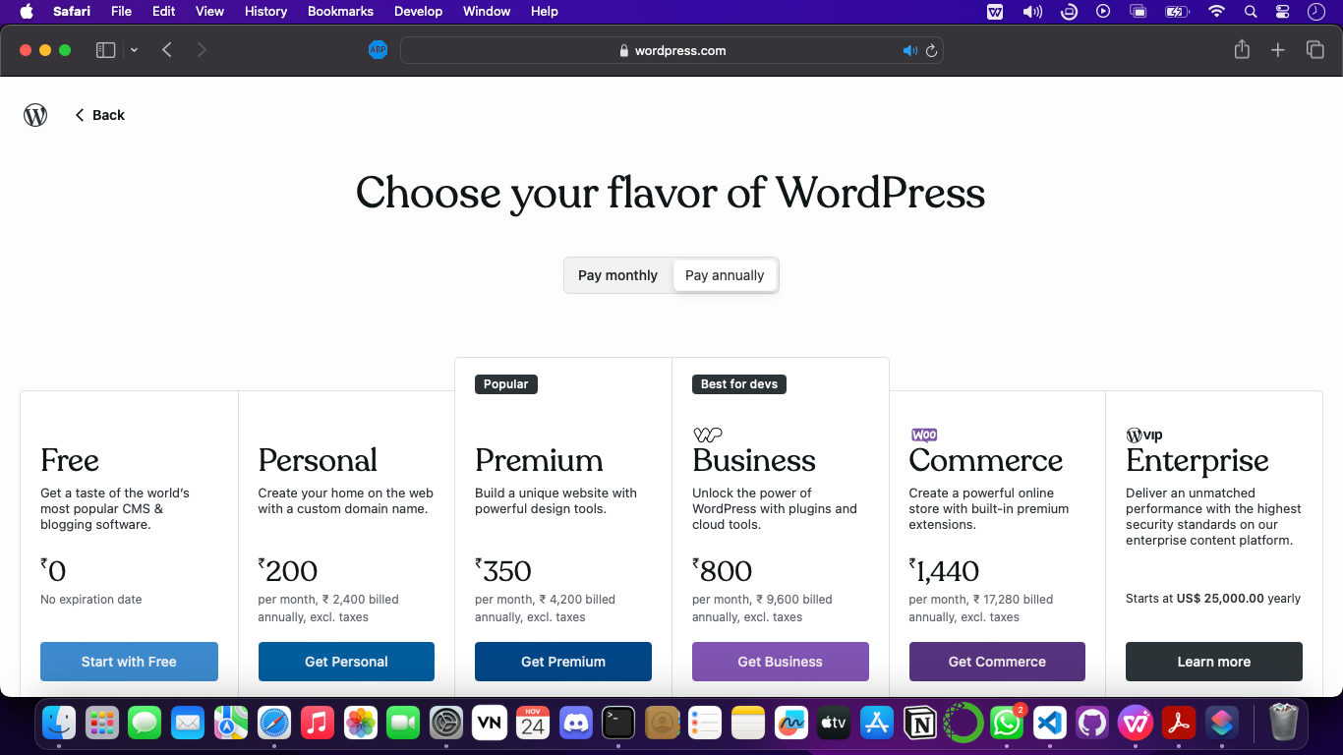

**Step 5 – Choose what is the goal of using the WordPress**

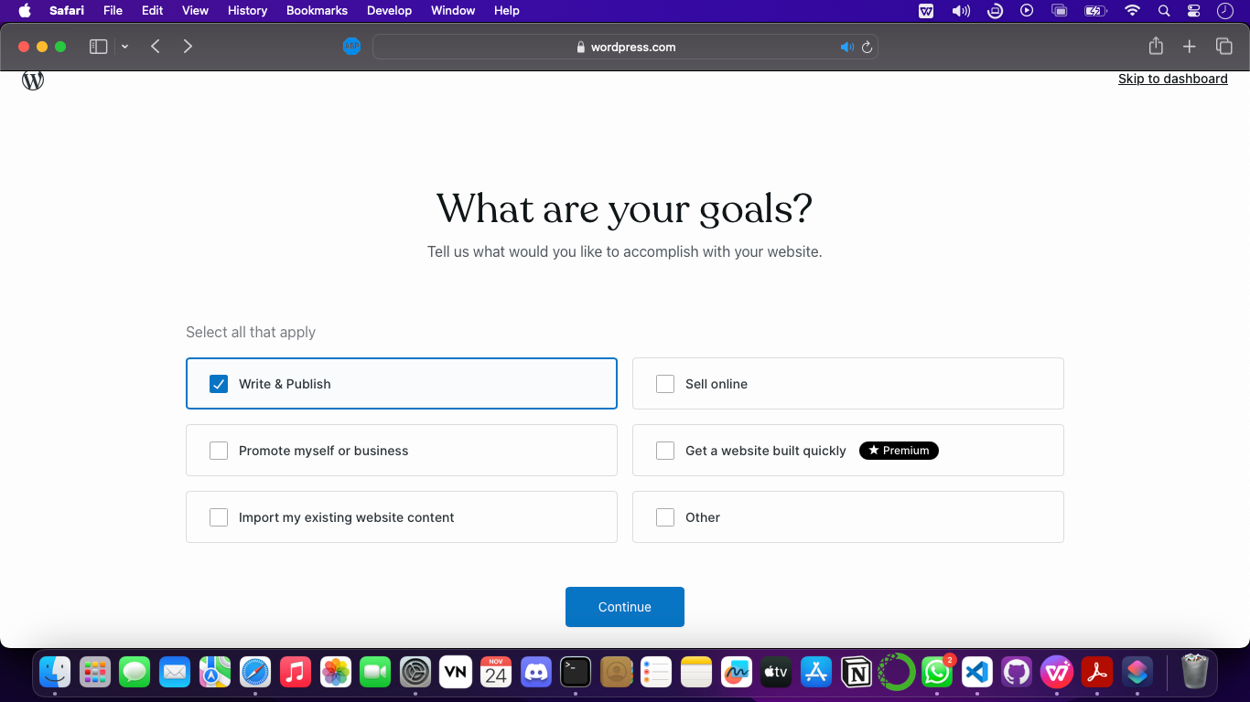

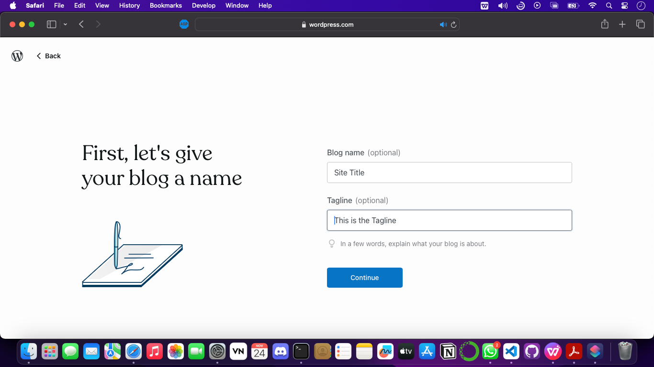

**Step 7 – Successfully Account is created**

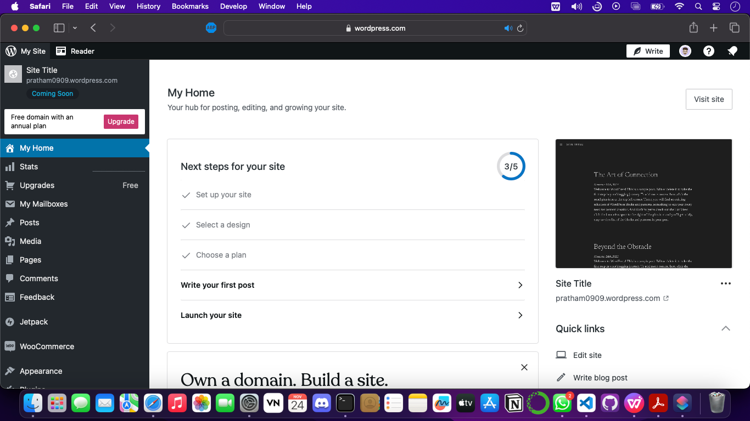

**Step 8. – By clicking write you can start building your own website**

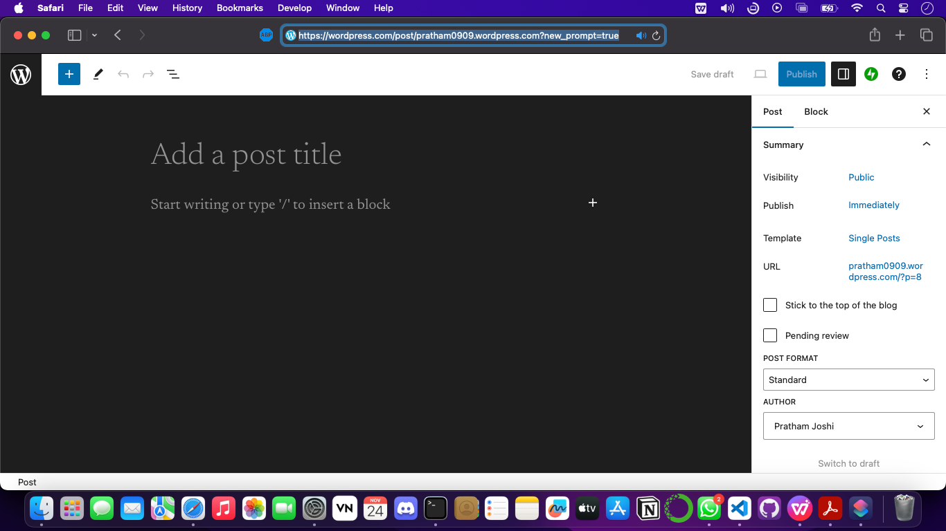

Here onward we can build the website as per your preferences and there are some templates also which you can edit can make it your own website.

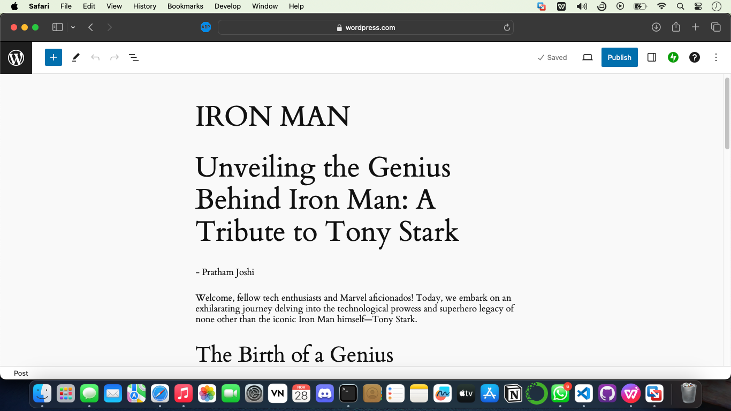

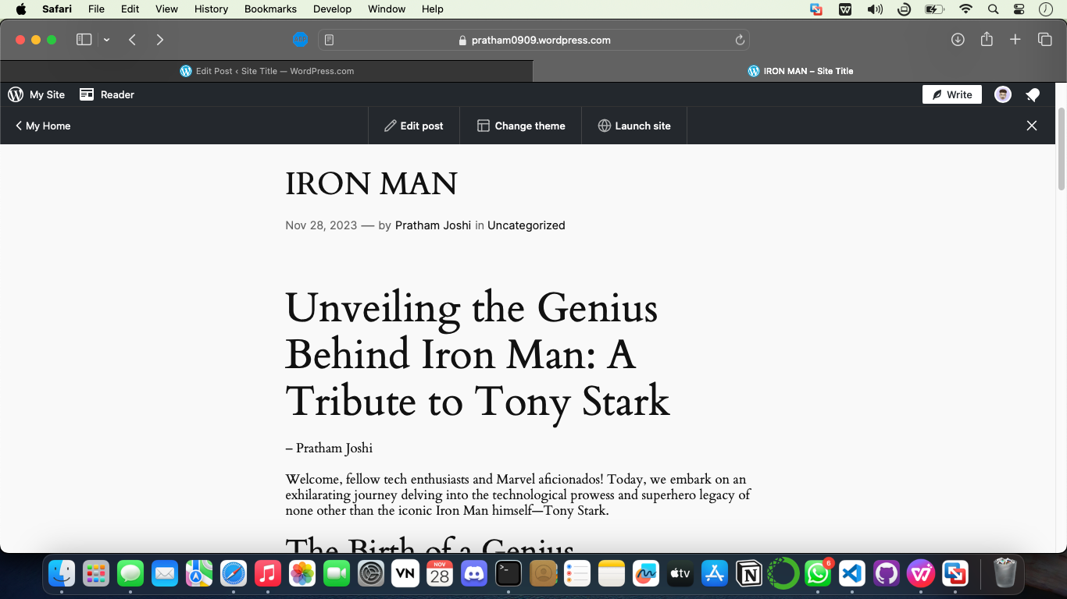<https://pratham0909.wordpress.com/2023/11/28/iron-man/>

For more information you can refer their documentation: <https://wordpress.com/support/getting-started-with-wordpress-com/>

**Conclusion-**

Sucessfully learnt Software as service (SaaS) using Free trial of WordPress